Requirements for Hackathon Web App Design

Remove all existing initial entries from the system.

Implement secure login and sign-up functionality for users.

Integrate push and email notifications for status updates.

For admin access, implement a restricted sign-in procedure so only authorized personnel can access administrative controls.
Restricted Admin Access: Implement a secure login system so that only authorized personnel can access administrative controls.

User & Admin Login: Provide separate login flows for regular users and administrators.

Copy ID Functionality: Add a button to easily copy complaint or user IDs for reference.

Admin Dashboard: Create a dashboard for administrators to view all complaints, update statuses, and manage reports efficiently.
Homepage: two separate buttons for user login and admin login
Add good navigation: back buttons to go back to the previous page easily.
Admin login and sign up button as well.
Design logo for app as well.

Admin people have to enter their own passkey that we developers provide and then only they can login as an admin.
Passkey is ykls_764
Font size bigger
2025 civic thing should come at bottom
Forgot password option as well.

Enhance the “Civic Connect” web app to be more mobile-friendly, transparent, and efficient for both users and admins.

1. Mobile Optimization
- Ensure all buttons and elements are clearly visible and easy to tap on small screens.
- Improve layout responsiveness for different mobile devices.
- Optimize navigation with large, clear icons and spacing.
- Make login and reporting flows simple and intuitive on mobile.

2. Department-Based Issue Management
- Add separate departments for issue requests (e.g., Electrical, Water, Medical, Sanitation, Roads).
- Each department should have its own admin dashboard to view, manage, and resolve department-specific complaints.
- Allow users to choose the relevant department when submitting a new issue.

3. Issue Tracking and Transparency
- Track and display timestamps for:
  - When the issue was reported
  - When it was acknowledged
  - When it was resolved
- Implement SLA tracking to measure how long each issue takes to resolve.
- Display a public dashboard showing real-time stats like:
  - Number of issues logged this month
  - Average resolution time per department
  - Percentage of issues resolved vs pending
  - Overall performance trends

4. User Feedback and Ratings
- Allow users to rate their satisfaction once an issue is marked as resolved.
- Use a simple 5-star or emoji-based rating system.
- Display aggregated satisfaction scores publicly per department.

5. Public Reporting Dashboard
- Create a public transparency page (modify the public dashboard page) showing:
  - Total issues reported this month
  - Department-wise performance metrics
  - Average time taken to resolve issues
  - Customer satisfaction ratings
- Use graphs and visual charts for better readability (e.g., bar charts, pie charts, or line graphs).

6. Overall Experience Enhancements
- Improve visual hierarchy and UI clarity on all devices.
- Ensure smooth transitions between pages (use animations if suitable).
- Include a “Track My Request” section for users to view live progress on their complaints. – replace this with track issue button and page.

Add the same kind of design and animations that you have done for the home and public dashboard buttons in the homepage to ALL other navigation buttons across the app.
Add the animation to the breadcrumb icon as well. Make it more sleak and more smoothly animated when it turns into a cross in the mobile phone version of the app.
These are the different departments:
Electrical Department, Water Department, Medical Department, Sanitation Department, Roads Department.
Once the admin logs in, prompt them to choose their department. Prompt with a select your department menu. Each department will be able to see the requests lodged for them and update the status of each request accordingly. They will also be able to see the rating the user have given them. When customer gives rating, notification should appear for both user and admin. Improve the rating animation for the user and give a link to a page where the user can give their feedback on whether they are satisfied with the result from the specific department.
For the sake of demonstrating, Average Resolution Time (Days) should be changed to Average Resolution Time (Hours).
Logout button for phone – add animation.

Forgot Password
Map also

make the reports page on the admin page only accessible using a different passkey. the passkey is: ljn_987

on the admin login page, prompt to login as admin or login as super admin. Define normal admin as able to access the admin dashboard to review, update and track reported issues, but define super admin as able to access the reports of each department and also the overall comparison report.

login as super admin passkey is: ykls_764
login as admin passkey is: ljn_987
Electrical Department - ljn_9871, Water Department - ljn_9872, Medical Department - ljn_9873, Sanitation Department - ljn_9874, Roads Department - ljn_9875.
admin department should be able to get notification of when user gives rating and feedback on resolved request / issue.

PASSKEYS:
To confirm the passkeys once again:
- Passkey for logging in as Super Admin: ykls_764
- Passkey for logging in as Department Admin: ljn_987
Department-specific passkeys:
- Electrical Department: ljn_9871
- Water Department: ljn_9872
- Medical Department: ljn_9873
- Sanitation Department: ljn_9874
- Roads Department: ljn_9875

- Prompts I used:
fix the notification functionality of both admin and user please
- do and add this feature: 🧾 Department Performance Reports – Admin and Department View
- 📈 Department-Specific Report Analysis
- add a seperate button on the admin dashboard for each specific department on their own page to view their own perfomance analysis report. make the reports page on the admin page only accessible using a different passkey. the passkey is: ljn_987. (use the same admin passkey verification admin login page layout for this).
- in Sanitation Department (Admin View) page add a Dedicated Department Analytics Button: For department-level administrators, I've added a prominent, clearly labeled button directly on their dashboard. This button, "View Performance Analytics," serves as a direct shortcut to their detailed department report, making it easier than ever to access their specific performance data. DO THIS FOR ALL DEPARTMENTS
- do this: 🔐 Admin and Super Admin Login Functionality
- login as admin passkey is: ljn_987 once accessed, should ask to choose which department to login to. for each department login, create passkeys. example for electrical department login, create passkey for accessing the dashboard of that department. Electrical Department - ljn_9871, Water Department - ljn_9872, Medical Department - ljn_9873, Sanitation Department - ljn_9874, Roads Department - ljn_9875. each department should be able to (without logging in or passkey), see its detailed perfomance analysis. (how long it took to resolve requests, how many requests it got in total, etc.) login as super admin passkey is: ykls_764 oncel logged in, should be able to access all departments without any login needed. Should be able to access the comparison of perfomance report analysis for all departments. use these hover animation tooltip texts as well: Here are short, clear tooltip texts you can use: Admin tooltip: Access the dashboard to review, update, and track user-reported issues. Super Admin tooltip: View detailed department reports and overall performance comparisons.
- once logged into department, on clicking view perfomance analysis, take the admin to a page where you actually give a perfomance analysis please. make the Department Performance and Efficiency Report accessible to each department admin once they click on "View Perfomance Analysis" button as well please.
- on the homepage, have only two buttons, user login / sign up and admin login. When admin login is pressed, prompt user to choose to login as a department admin or super admin. define the roles of admin and super admin as well like how you have defined the how it works section on the homepage.
- remove the go to public reports button functionality on public dashboard page.
- remove the public reports button in the navigation. only include home and public dashboard as the two buttons.
- Google Maps Platform rejected your request. The provided API key is invalid. fix this error.
- To confirm the passkeys once again: Passkey for logging in as Super Admin: ykls_764 Passkey for logging in as Department Admin: ljn_987 Department-specific passkeys: Electrical Department: ljn_9871 Water Department: ljn_9872 Medical Department: ljn_9873 Sanitation Department: ljn_9874 Roads Department: ljn_9875 update these and use only these.
- fix the forgot password functionality and make it work properly. use backend as appropriate. also send the user the notification on their actual mail as well.
- On the public dashboard, display a dynamic leaderboard featuring the top 5 most active citizens/users. Each entry should include the user's name, profile picture (if available), total activity score or points, and a concise summary of their contributions (such as the number of reports submitted or issues resolved). The leaderboard should update automatically in real-time or at regular intervals to reflect the latest activity levels, ensuring users can track top contributors easily.
- on All Departments Overview page, for resolution type, change Average Resolution Time (Days) to Average Resolution Time (Minutes) and add a not that this is for demo purposes only.
- While the user is filling out a report, automatically suggest the appropriate department by analyzing the event title, description and selected category using AI. If the AI is unable to confidently determine the department, provide the user with an option to select it manually.
- On the admin home page, add a button to view the performance analysis of departments alongside the existing 'Go to Admin Dashboard' button.
- change button text from view perfomance analysis to view perfomance analytics.
- On the Performance and Efficiency Report for each department: Change Average Resolution Time from days to minutes. Change Avg. Resolution Time Trend (Last 8 Weeks) to Avg. Resolution Time Trend (Last Week). Add a note stating: “Note: This conversion to minutes and the trend adjustment are for demonstration purposes only; the actual metrics are measured in days.”
- place the note at a more appropriate place and make it look a lot better
- on homepage, make the admin login button also a colored gradient background, similar to the user login / sign up button.
- center the no activity note in the Top Active Citizens container. make the Select Your Admin Role page more beautiful. use colors to make it pop. add more animations.
- add more animations in the home page. make each container hover and float when cursor is on top of it. add more animations.
- Enhance the home page with additional hover animations. Make each container subtly float or lift when the cursor hovers over it, adding a dynamic, interactive feel to the interface.
- make the login pages for admins and users more beautiful and add more animations as well. make it look amazing.
- remove the civic connect logo on the login and sign up forms for both users and admins. just keep the form. make it more animated though, make it look better.
- Focused Form-First Design: The "Civic Connect" logo and header have been removed from all authentication screens. The interface is now centered entirely around the form itself, creating a clean, professional, and distraction-free experience. do this
- Enhancements for Buttons: Department Admin Access Page Button: Continue Action: Add colorful styling (gradient or vibrant color scheme) Animation: Smooth hover effects (e.g., color shift, slight scale-up, shadow glow) Super Admin Login Page Button: Authenticate Action: Apply vibrant, eye-catching colors Animation: Interactive hover and click effects (e.g., bounce, pulse, or glow) Goal: Make both buttons visually engaging and provide a dynamic, modern user experience.
- An image-based request to improve the color scheme of the "Authenticate" button on the Super Admin Login page.
- An image-based request to improve the color scheme of a button on the Admin Portal Access page.
- add the same animations as you have done for the authenicate button on the super admin login page to the continue button on the department admin access page.
- make the continue button the same color as the login as department admin button.

THINGS TO DO:
- Forgot password – try to do it
- Sending actual mails or sms to the user.
- Notification problem
- Designing left
- Segregating github repositories for backend and frontend
- Automating department choice when user fills event description and category while issuing a report using AI – problem faced if anything other than garbage is entered as event title
- Back button after choosing department for super admin
- Demo Video filming

Changes to make:

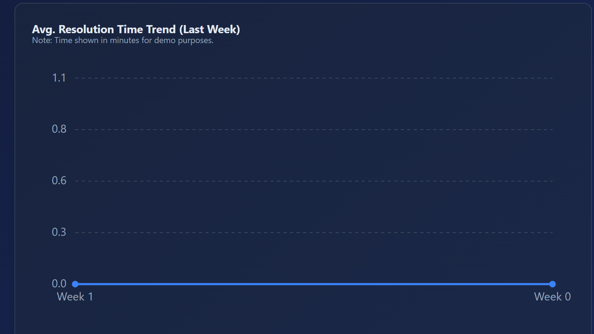

Change last week to last 2 days maybe. – THIS IS FINE

When admins, super admins and users login, take them to the homepage always first. - Done

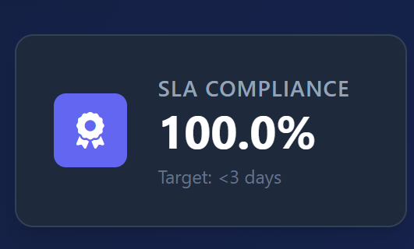
Here also, change it to hours. Target: <3 hours. Mention it’s for demo purposes. - DONE
Also mention tootltip hover text for the admin to know what SLA means. – DONE
Why 100%? – NOT DONE

Add a lot better smooth animations to the breadcrumb button please.
Make border around it once user hovers on top (same as other buttons in the web app). - DONE

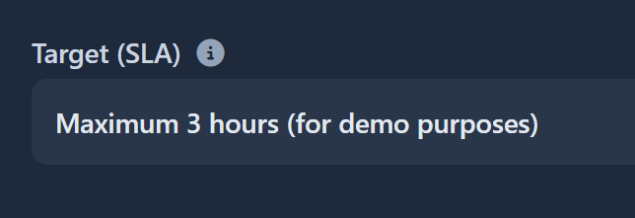

Add here that the actual time would be measured in days. - DONE

Add change department button once admin has logged into their specific department to allow the admin to easily login to another department if they have to. - DONE

Add notifications for admins as well once they update the status of a report, example: you have marked the status of ___ report as “Resolved”. Also, notifications should be displayed once user gives feedback, the text of the feedback the user gave and the rating the user gave. - DONE

Also work on sending notifications to the user directly to their mail or sms using backend. You can tell google ai studio to remove the simulated email functionality once the notifications are successfully being delivered to the user on their mail or sms.

Choose a department could be a drop down menu listing all the departments. Or not. Better actually not. – NOT REQUIRED

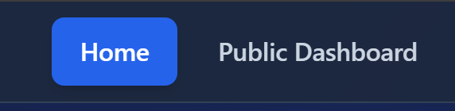

Make the color of these button gradient (keep it blue though). – not required

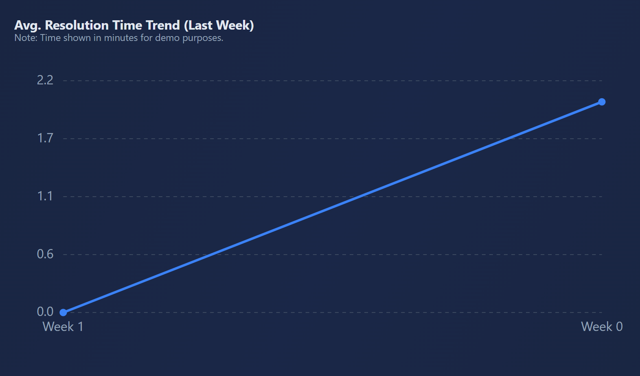
Label y axis in minutes here for better understanding. – ITS OK

Ask that the overdue cases means to google ai studio. How long does it need to take for a department to resolve an issue and for it to be marked as overdue?
You can add tooltip hover text on top to make the admin understand how long it takes for a issue/case to be marked as overdue. - DONE
- Automating department choice when user fills event description and category while issuing a report using AI – problem faced if anything other than garbage is entered as event title
Improve the AI greatly to understand what department it is and make sure it is correct. - DONE
- Add a back button after choosing department for super admin - DONE
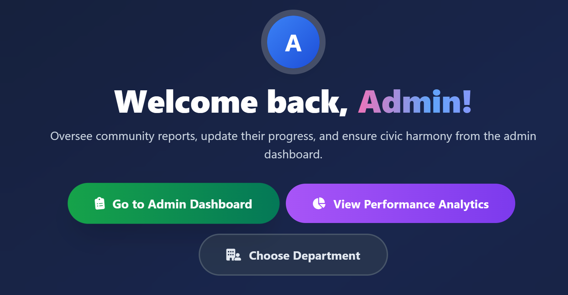
Make choose department here colored. - ALMOST DONE
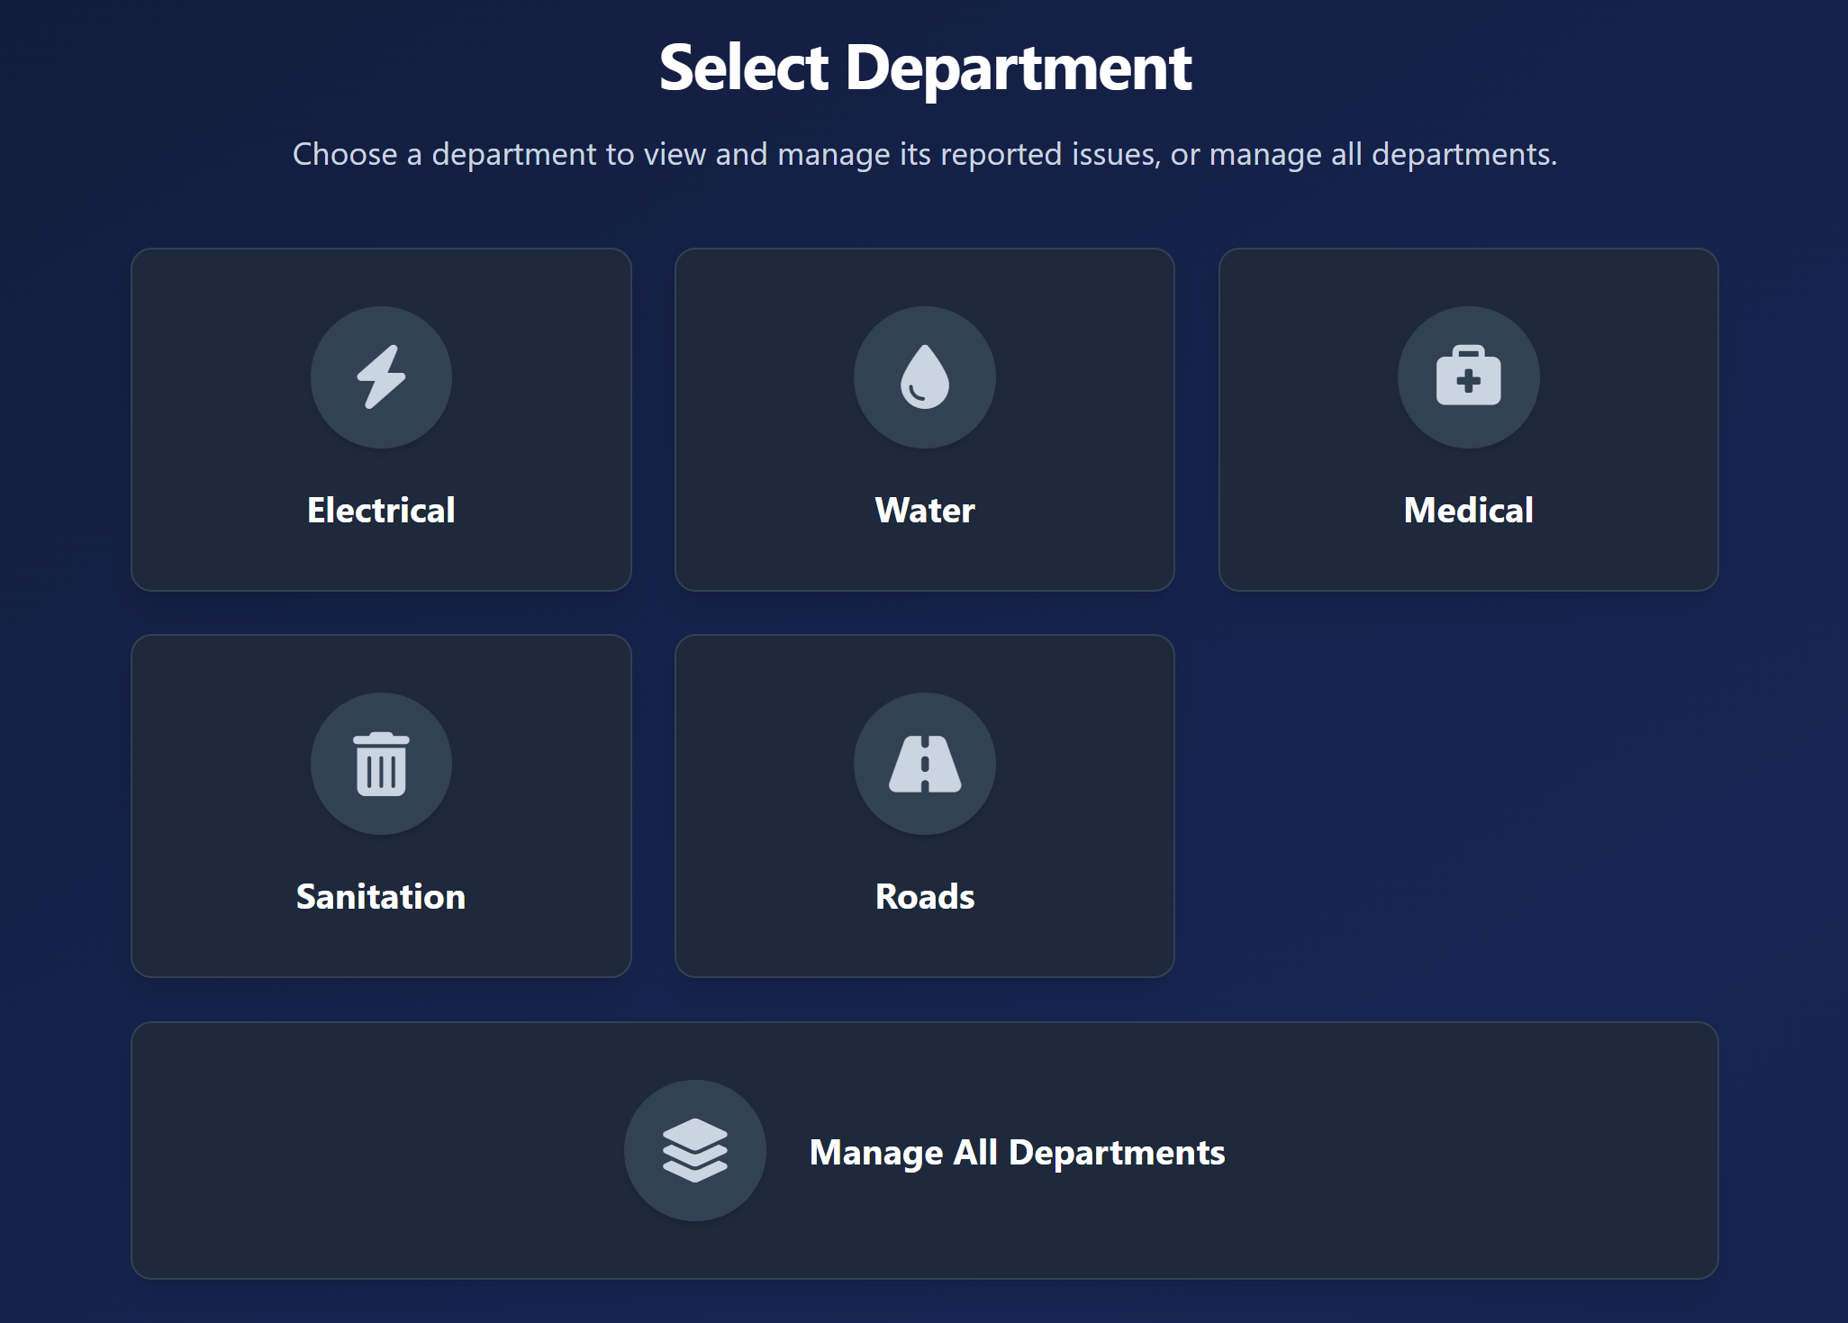
Make this part also very much more beautiful, add vibrant colors and more better animations. - DONE

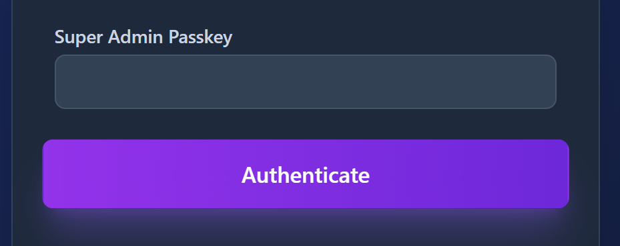
Make the animation of this button here universal for all other pages in the web app. Add a static color (vibrant blue or purple) and remove gradient. Keep everything else the same. – NOT REQUIRED

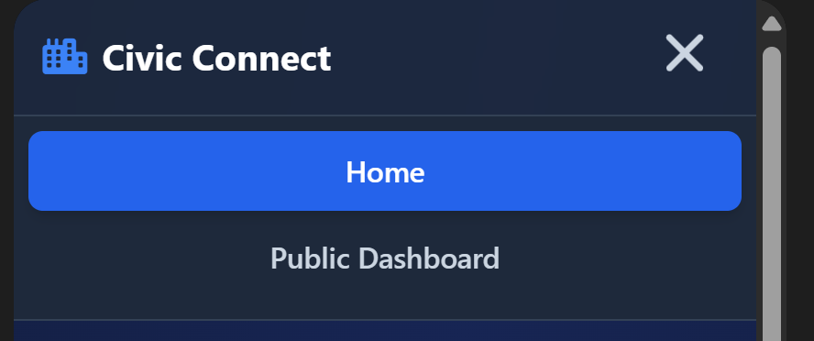
Improve the animation when the breadcrumb button is clicked (the animation of opening the menu – make that a lot better and smoother).

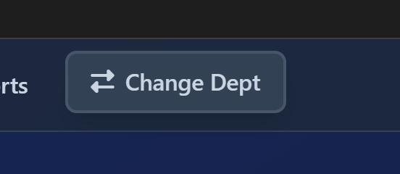

Add color to this button. – NOT REQUIRED

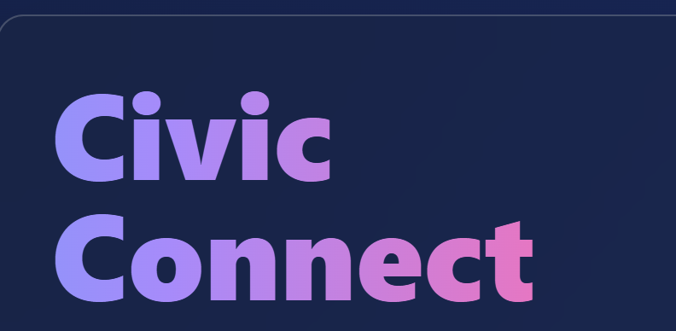
Make the gradient of this only blue to some other dark blue. – NOT REQUIRED

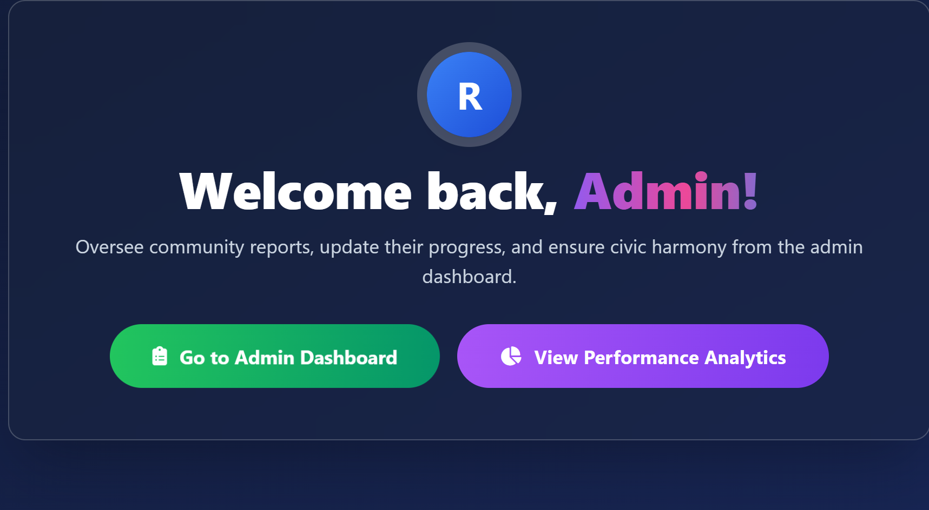
Add change department button here as well. – DONE

NOTIFICATION ON MAIL OR SMS FOR USER
AND
FORGOT PASSWORD MAIL TO USER

WORK ON LIGHT MODE AND DARK MODE (ICON IS ALREADY THERE)

